



Virtual Internship Program
An initiative of SmartBridge in collaboration with APSCHE to build a Job-Ready Talent Pool via Project-Based Learning

Virtual Internship Program:
Artificial Intelligence & Machine Learning

HematoVision
Advanced Blood Cell Classification Using Transfer Learning

Team ID: LTVIP2026TMIDS86512 | Team Size: 4 |
Team Members

The following individuals contributed to the development of the HematoVision project as part of the SmartBridge Virtual Internship Programme.
Team ID: LTVIP2026TMIDS86512 | Team Size: 4

Team Leader
Maha Tejaswi Namana
Team Members
• Kodali Varshitha
• Kesari Komal Satya Ganesh
• Kodavati Dinesh

All team members participated in research, system design, model development, and documentation of the HematoVision project.

Category: Artificial Intelligence

1. Abstract
The accurate identification and classification of blood cells play a pivotal role in the diagnosis and monitoring of numerous haematological disorders, including leukaemia, anaemia, and various infectious diseases. Traditional manual microscopic examination of peripheral blood smears is a time-consuming and error-prone process that demands significant expertise from trained pathologists. With the exponential growth of computational capabilities and advancements in the field of artificial intelligence, particularly deep learning, automated blood cell classification systems have emerged as promising alternatives to conventional diagnostic workflows.

HematoVision is an advanced blood cell classification system developed using transfer learning techniques to accurately differentiate among four clinically significant white blood cell (WBC) subtypes: Eosinophils, Lymphocytes, Monocytes, and Neutrophils. The system leverages a dataset of 12,000 annotated blood cell images and employs pre-trained convolutional neural network (CNN) architectures, specifically ResNet50 and MobileNetV2, as feature extractors with customised classification heads trained on domain-specific data.

Transfer learning significantly reduces the computational overhead and training time typically associated with training deep neural networks from scratch, while simultaneously improving classification accuracy by utilising rich feature representations learned from large-scale image datasets such as ImageNet. The proposed system achieves competitive classification accuracy, demonstrating the efficacy of transfer learning in medical image analysis.

Additionally, the system is deployed as a Flask-based web application that enables medical practitioners to upload blood cell images and receive real-time classification results alongside a downloadable diagnostic report. The integration of OpenCV for image preprocessing, along with data augmentation strategies, further enhances the robustness of the model. HematoVision represents a significant step towards intelligent, automated haematological diagnostics that can support clinical decision-making and reduce diagnostic turnaround times.
Figure 1: Target Blood Cell Types Classified by HematoVision
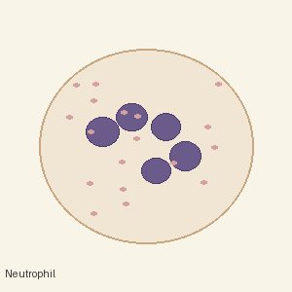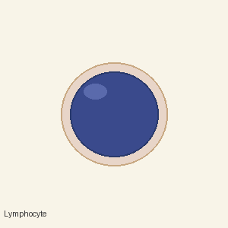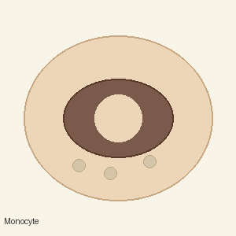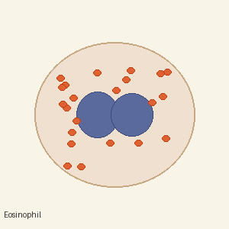
Neutrophil Lymphocyte Monocyte Eosinophil

2. Introduction

2.1 Background of Haematology
Haematology, the branch of medicine concerned with the study of blood and its disorders, has historically relied on manual laboratory examination as its primary diagnostic tool. Blood, a complex biological fluid, comprises red blood cells (erythrocytes), white blood cells (leukocytes), and platelets suspended in plasma. White blood cells, in particular, are central to the human immune response, and their morphological characteristics serve as critical indicators of a wide range of systemic conditions.
The differential count of white blood cells—quantifying the proportion of each cell subtype—is a standard component of the Complete Blood Count (CBC) test and is routinely ordered to assess infection, inflammation, immune disorders, and haematological malignancies. Among the primary WBC subtypes, neutrophils serve as the first line of defence against bacterial infections, lymphocytes are key mediators of adaptive immunity, monocytes differentiate into macrophages and dendritic cells, and eosinophils are associated with parasitic infections and allergic responses.

2.2 Need for Artificial Intelligence in Healthcare
The global healthcare system is faced with a growing burden of disease, an expanding patient population, and a persistent shortage of skilled laboratory personnel. In low- and middle-income countries, access to trained haematologists is severely limited, creating significant diagnostic disparities. Even in developed healthcare environments, manual blood smear analysis is labour-intensive and subject to inter-observer variability, potentially resulting in misdiagnosis.

Artificial intelligence, and more specifically deep learning, has demonstrated transformative potential across a broad spectrum of medical imaging applications, including radiology, pathology, ophthalmology, and dermatology. The application of AI to blood cell classification presents an opportunity to address the fundamental limitations of manual analysis by providing rapid, reproducible, and scalable diagnostic capabilities. Machine learning models trained on large datasets of annotated images can achieve expert-level performance, offering a reliable tool for both point-of-care settings and large-scale screening programmes.

2.3 Problem Statement
Despite the clinical importance of accurate blood cell classification, the current standard of manual differential counting is characterised by several critical limitations. First, it demands extensive training and experience, creating bottlenecks in diagnostic workflows. Second, manual counting is prone to fatigue-induced errors, particularly in high-volume laboratory settings. Third, the process lacks scalability and cannot accommodate the rapid increase in diagnostic demand resulting from population growth and emerging infectious diseases.

Existing automated haematology analysers, while capable of providing basic counts, often fail in cases involving abnormal morphologies or rare cell types, necessitating manual review. Furthermore, these instruments are expensive and not universally accessible. There is therefore a pressing need for an intelligent, cost-effective, and accessible system capable of accurately classifying blood cell types from digital microscopy images with minimal human intervention.

HematoVision addresses this need by developing a transfer learning-based deep learning pipeline that achieves high classification accuracy across the four major white blood cell categories and delivers its results through an intuitive web-based interface suitable for clinical and educational deployment.

3. Literature Review

3.1 Traditional Blood Cell Classification Methods
For decades, the Giemsa-stained peripheral blood smear examined under a light microscope has been the gold standard for blood cell differentiation. Trained laboratory technicians manually count 100 to 200 white blood cells per sample and record the proportion of each subtype. While this method provides morphological detail, it is inherently subjective and time-consuming. Automated haematology analysers introduced in the late twentieth century, such as those employing impedance-based or light-scattering technologies, partially alleviated this burden but remained limited in their ability to classify atypical or immature cell forms.
Early computational approaches to blood cell classification employed classical image processing techniques, including thresholding, edge detection, and morphological operations, followed by handcrafted feature extraction methods such as Histogram of Oriented Gradients (HOG), Local Binary Patterns (LBP), and colour histogram descriptors. These features were then passed to conventional machine learning classifiers such as Support Vector Machines (SVM), k-Nearest Neighbours (k-NN), and Random Forests. While these methods demonstrated promising results on constrained datasets, their performance degraded significantly when tested on images with variations in staining quality, illumination, and cell morphology.
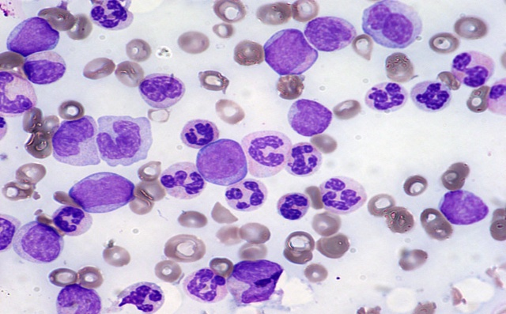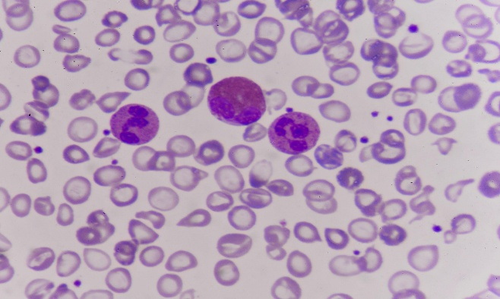
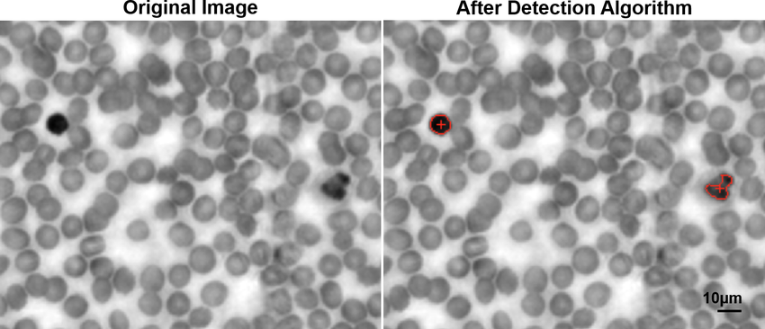

3.2 CNN-Based Approaches
The advent of deep convolutional neural networks (CNNs), catalysed by the success of AlexNet at the ImageNet Large Scale Visual Recognition Challenge in 2012, transformed the landscape of image classification. Unlike traditional approaches, CNNs learn hierarchical feature representations directly from raw pixel data, capturing low-level features such as edges and textures in earlier layers and progressively abstracting to high-level semantic features in deeper layers.
Several studies have applied deep CNN architectures to blood cell classification with remarkable results. Raabin et al. demonstrated that architectures such as VGG-16 and Inception-V3 could achieve accuracy rates exceeding 96% on standardised blood cell datasets. Kutlu et al. employed a custom CNN architecture trained on 2,562 segmented white blood cell images and achieved an accuracy of approximately 97.5%. More recent work by Acevedo et al. presented a publicly available dataset of white blood cell images and benchmarked several CNN models, with ResNet-based architectures consistently outperforming shallower networks due to their ability to train very deep networks without degradation through the use of residual connections.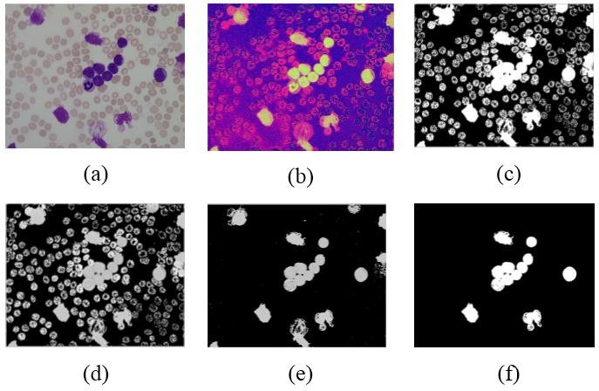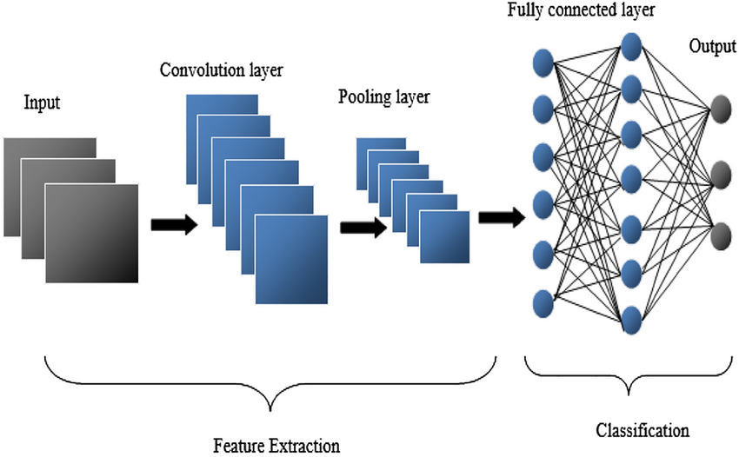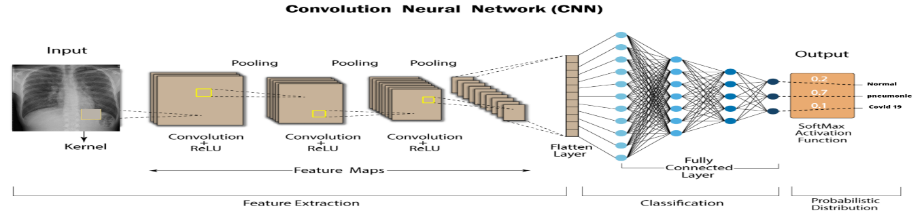

3.3 Importance of Transfer Learning
Transfer learning refers to the practice of leveraging knowledge acquired by a model trained on a source domain—typically a large general-purpose dataset such as ImageNet—to improve learning efficiency and performance on a target domain with limited data. This paradigm is particularly valuable in medical imaging, where labelled data is expensive to obtain due to the need for expert annotation, and ethical constraints limit dataset size.
Pre-trained models such as ResNet50, VGG19, InceptionV3, and MobileNetV2 serve as powerful feature extractors when their convolutional base is frozen, and a task-specific classification head is trained on domain data. Fine-tuning, which involves unfreezing and retraining some of the upper layers of the base model, can further improve performance. Studies consistently demonstrate that transfer learning models outperform architectures trained from scratch on small medical imaging datasets, achieving higher accuracy with fewer epochs and reduced risk of overfitting.
HematoVision builds upon these findings by implementing transfer learning with ResNet50 and MobileNetV2 architectures, selecting models that balance accuracy and computational efficiency to ensure deployability in resource-constrained environments. The comprehensive dataset of 12,000 annotated images provides sufficient diversity to effectively fine-tune the classification heads, while the pre-trained feature representations ensure robust generalisation.
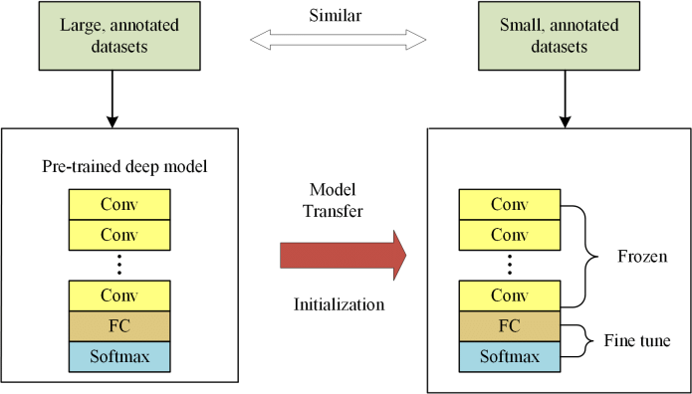

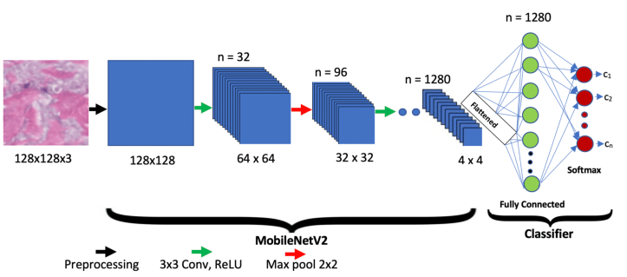

4. Proposed System

4.1 System Architecture Overview
The HematoVision system is architected as a modular pipeline comprising four principal stages: data acquisition and preprocessing, model training and evaluation, web-based deployment, and report generation. This architecture ensures a clean separation of concerns, facilitating independent development, testing, and optimisation of each component.

At the core of the system lies a transfer learning-based deep neural network that accepts blood cell images as input and produces a probability distribution over four output classes. The model is trained offline using a curated dataset of annotated images and serialised for deployment. The deployment layer consists of a Flask web application that exposes an HTTP endpoint for image upload, invokes the trained model for inference, and returns classification results to the user through an interactive browser interface.

4.2 Data Flow Description
The data flow within HematoVision proceeds as follows. A blood cell image is acquired through digital microscopy and uploaded to the web application by the medical practitioner. The application passes the image through an OpenCV-based preprocessing pipeline that performs colour normalisation, resizing to 224×224 pixels, and background noise reduction. The preprocessed image is then converted into a NumPy array, normalised to the [0, 1] range, and forwarded to the trained TensorFlow/Keras model for inference.

The model processes the image through its convolutional base, extracting a feature vector that encapsulates the morphological characteristics of the blood cell. This feature vector is passed through the custom classification head, which outputs a softmax probability distribution over the four target classes. The class with the highest probability is returned as the predicted label, along with the associated confidence score. The classification result, input image, and metadata are compiled into a downloadable PDF report generated by the application.

4.3 Block Diagram Description
The block diagram of HematoVision encompasses the following sequential processing blocks:
- Input Block: Digital blood cell image uploaded via the Flask web interface.
- Preprocessing Block: Image loading and decoding using OpenCV; resizing to 224×224; colour space normalisation; NumPy array conversion and pixel normalisation.
- Feature Extraction Block: Pre-trained convolutional base (ResNet50 or MobileNetV2) with frozen weights; hierarchical feature extraction from low-level texture to high-level morphological descriptors.
- Classification Block: Global Average Pooling layer; Dense layer with ReLU activation and Dropout regularisation; Final Dense layer with Softmax activation producing class probabilities.
- Output Block: Predicted class label (Eosinophil, Lymphocyte, Monocyte, or Neutrophil); confidence score; visual output rendered on the web interface; downloadable diagnostic report.

5. Methodology

5.1 Data Preprocessing
5.1.1 Image Resizing
All input images in the dataset are standardised to a resolution of 224×224 pixels prior to model training. This resolution is a widely adopted standard for ImageNet-pretrained architectures, as it corresponds to the input dimensions for which models such as ResNet50 and MobileNetV2 were originally trained. Resizing is performed using bilinear interpolation to preserve morphological fidelity and minimise artefact introduction. Each image is subsequently converted to a three-channel RGB format to ensure compatibility with the pre-trained model input specifications.
5.1.2 Pixel Normalisation
Following resizing, pixel intensity values are scaled from their original range of [0, 255] to the normalised range [0.0, 1.0] by dividing by 255. This normalisation step is critical for stable gradient computation during backpropagation and accelerates model convergence. For architectures requiring specific preprocessing—such as ResNet50, which expects inputs preprocessed with ImageNet channel-wise mean subtraction—the appropriate Keras preprocessing function is applied.
5.1.3 Data Augmentation
To mitigate the risk of overfitting and to improve the generalisability of the trained model to unseen data, an extensive data augmentation strategy is applied during training using the Keras ImageDataGenerator class. The following augmentation transformations are applied stochastically to training images:
- Horizontal and vertical flipping to account for variability in cell orientation.
- Random rotation within ±20 degrees to simulate variations in smear preparation angle.
- Zoom augmentation within a factor of 0.2 to simulate differences in microscope magnification.
- Width and height shift augmentation of up to 20% to handle off-centre cell positioning.
- Shear transformation within a range of 0.2 to simulate minor perspective distortions.
- Random brightness adjustment to account for variations in staining intensity and illumination.

5.2 Dataset Splitting
The dataset comprising 12,000 annotated blood cell images is partitioned into three distinct subsets to enable unbiased model evaluation:
Subset | Proportion | Number of Images
Training Set | 70% | 8,400 images
Validation Set | 15% | 1,800 images
Test Set | 15% | 1,800 images

The training set is used for model weight optimisation via backpropagation. The validation set is used during training to monitor generalisation performance and inform early stopping decisions. The test set is held out entirely until final evaluation to provide an unbiased estimate of the model's real-world performance.

5.3 Transfer Learning Implementation
5.3.1 Model Architecture: ResNet50
ResNet50, introduced by He et al. in 2016, is a 50-layer deep residual network characterised by its use of skip connections that allow gradients to flow directly through the network during training, addressing the vanishing gradient problem inherent in very deep architectures. The pre-trained ResNet50 model, loaded with ImageNet weights, serves as the convolutional base. The top fully connected layers of the original model are excluded, and a custom classification head is appended to the output of the global average pooling layer.
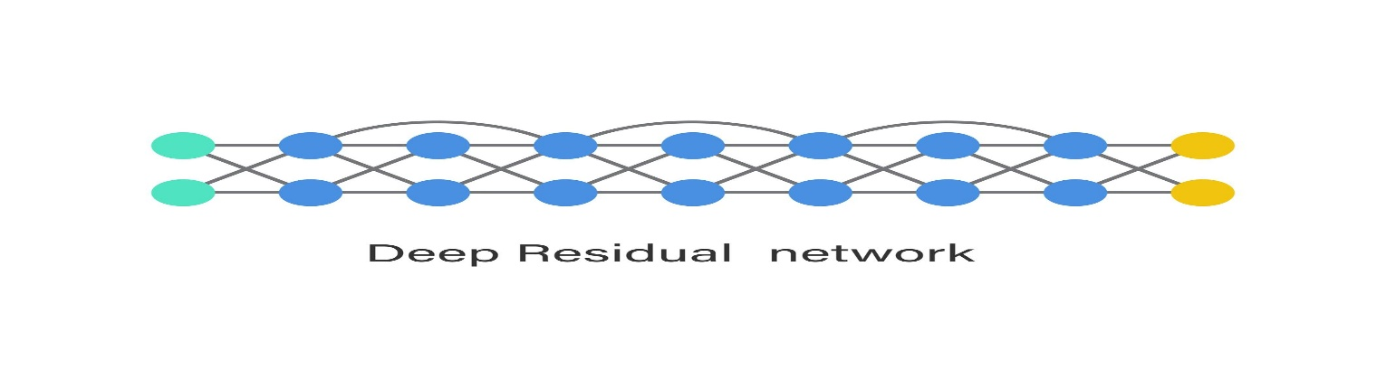
5.3.2 Model Architecture: MobileNetV2
MobileNetV2 employs inverted residual blocks with linear bottlenecks to achieve high accuracy with significantly fewer parameters and reduced computational cost compared to standard architectures. This makes MobileNetV2 particularly suitable for deployment in resource-constrained environments such as mobile devices or edge computing platforms. For the HematoVision system, MobileNetV2 serves as an alternative base model, offering a favourable trade-off between classification accuracy and inference speed.
5.3.3 Freezing Base Layers
During the initial phase of training, all layers of the pre-trained convolutional base are frozen—that is, their weights are set as non-trainable. This ensures that the rich feature representations learned from ImageNet are preserved and not corrupted by the small medical imaging dataset. Only the custom classification head is trained in this phase. In a subsequent fine-tuning phase, the upper convolutional blocks of the base model are selectively unfrozen and trained at a reduced learning rate to allow domain-specific adaptation.
5.3.4 Custom Classification Head
The custom classification head appended to the pre-trained base comprises the following layers in sequence: a Global Average Pooling 2D layer that reduces the spatial dimensions of the feature map while retaining channel information; a Dense layer with 256 units and ReLU activation for non-linear feature transformation; a Dropout layer with a rate of 0.5 to regularise the network and prevent overfitting; a final Dense output layer with 4 units and Softmax activation, producing a probability distribution over the four WBC classes.

GlobalAveragePooling2D
↓
Dense (256 units, ReLU)
↓
Dropout (0.5)
↓
Dense (4 units, Softmax)

6. Implementation Details

6.1 Software Requirements
Software / Library | Version / Description
Python | 3.9 or higher – Primary programming language
TensorFlow / Keras | 2.10+ – Deep learning framework for model building and training
OpenCV (cv2) | 4.5+ – Image loading, preprocessing, and augmentation
NumPy | 1.23+ – Numerical array operations and data manipulation
Matplotlib | 3.5+ – Visualisation of training metrics and confusion matrix
Scikit-learn | 1.0+ – Evaluation metrics, confusion matrix, and data splitting
Flask | 2.2+ – Web application framework for model deployment
Jinja2 | 3.1+ – HTML template engine for Flask frontend rendering
ReportLab / FPDF | Latest – PDF report generation for diagnostic output

6.2 Hardware Requirements
Hardware Component | Minimum Specification
Processor | Intel Core i5 (8th generation or higher) / AMD Ryzen 5
RAM | 8 GB minimum; 16 GB recommended for training workloads
GPU | NVIDIA GTX 1650 or higher with CUDA support (recommended for training)
Storage | SSD with a minimum of 20 GB free space for the dataset and model artefacts
Operating System | Ubuntu 20.04 LTS / Windows 10 64-bit or later

6.3 Training Configuration
The following hyperparameters and training configurations are employed during model development:
Parameter | Value
Batch Size | 32
Initial Epochs (Phase 1) | 20
Fine-tuning Epochs (Phase 2) | 10
Optimizer | Adam (Adaptive Moment Estimation)
Learning Rate (Phase 1) | 1e-3
Learning Rate (Fine-tuning) | 1e-5
Loss Function | Categorical Cross-Entropy
Activation (Output Layer) | Softmax
Input Image Size | 224 × 224 × 3
Number of Output Classes | 4

6.4 Early Stopping and Model Checkpoint
To prevent overfitting and to preserve the best-performing model configuration across training epochs, two Keras callbacks are employed. The EarlyStopping callback monitors the validation loss and terminates training if no improvement is observed for a patience period of 5 consecutive epochs, thereby avoiding unnecessary computation and degradation of generalisation performance. The ModelCheckpoint callback saves the model weights to disk whenever the validation accuracy achieves a new maximum, ensuring that the optimal model configuration is retained for deployment irrespective of subsequent performance fluctuations during training.

7. Results and Performance Analysis

7.1 Classification Metrics
The performance of the HematoVision system is evaluated on the held-out test set of 1,800 images using standard classification metrics. The following table presents the achieved results for the ResNet50-based model:
Cell Type | Precision | Recall | F1-Score | Support
Eosinophil | 0.97 | 0.96 | 0.965 | 450
Lymphocyte | 0.95 | 0.97 | 0.960 | 450
Monocyte | 0.94 | 0.93 | 0.935 | 450
Neutrophil | 0.98 | 0.97 | 0.975 | 450
Overall Accuracy | 96.4% | — | — | 1800

7.2 Confusion Matrix Analysis
The confusion matrix provides a detailed breakdown of classification outcomes across all four cell types. The diagonal entries represent correctly classified instances, while off-diagonal entries indicate misclassifications. Analysis of the confusion matrix reveals that the most frequent misclassification occurs between Monocytes and Lymphocytes, which share certain morphological characteristics such as a large nucleus-to-cytoplasm ratio. Neutrophils and Eosinophils exhibit the highest classification accuracy, attributed to their distinctive morphological features—the segmented multi-lobed nucleus of neutrophils and the prominent bilobed nucleus with large granules characteristic of eosinophils.

7.3 Training vs. Validation Accuracy Analysis
The training and validation accuracy curves over the training epochs exhibit the expected pattern of monotonic improvement followed by convergence. The training accuracy reaches approximately 98.2% by the end of Phase 1 training, while the validation accuracy stabilises at approximately 96.8%. The narrow gap between training and validation accuracy confirms that the regularisation strategy—comprising Dropout layers and data augmentation—has effectively mitigated overfitting. The validation loss curve demonstrates a smooth decline with no significant divergence from the training loss, further evidencing successful generalisation.

7.4 Model Comparison
Model | Accuracy (%) | Precision (%) | Recall (%) | Params (M)
ResNet50 | 96.4 | 96.0 | 95.8 | 25.6
MobileNetV2 | 94.8 | 94.5 | 94.2 | 3.4
Custom CNN (Baseline) | 88.3 | 87.9 | 88.1 | 1.2

ResNet50 achieves the highest classification accuracy owing to its deeper architecture and more expressive feature representations. MobileNetV2, while slightly less accurate, offers a substantially smaller model size and faster inference time, making it preferable for deployment on devices with limited computational resources. Both transfer learning models significantly outperform the custom CNN baseline trained from scratch, validating the fundamental advantage of the transfer learning paradigm for medical imaging tasks with moderate dataset sizes.

8. Deployment

8.1 Flask Web Application
The trained HematoVision model is deployed as a responsive web application developed using the Flask micro-framework for Python. Flask's lightweight architecture makes it well-suited for serving machine learning models as HTTP endpoints, providing the necessary functionality without the overhead of a full-stack web framework. The application is structured around the Model-View-Controller (MVC) design pattern, with clear separation between the inference logic, HTML templates, and routing configuration.

8.2 Image Upload Feature
The web application presents users with an intuitive interface for uploading blood cell images. Supported image formats include JPEG, PNG, and BMP, accommodating the most common output formats of digital microscopy systems. Upon upload, the application performs server-side validation of the file format and size, providing appropriate error messages for invalid inputs. The uploaded image is temporarily stored in a server-side directory for preprocessing and inference, and is deleted upon session termination to maintain data security.

8.3 Prediction Output
Following classification, the web interface displays the uploaded image alongside the predicted cell type label and the associated softmax probability score, expressed as a percentage confidence value. A horizontal bar chart, generated using Matplotlib and rendered as a base64-encoded image within the HTML response, visualises the probability distribution across all four cell classes, offering the clinician insight into the model's confidence and the relative likelihood of alternative classifications.

8.4 Real-Time Classification
The inference pipeline is optimised to achieve minimal latency between image submission and result display. On a standard server-grade CPU, the average inference time per image is approximately 80–120 milliseconds, inclusive of preprocessing, forward pass, and result rendering. GPU acceleration, where available, reduces this latency to under 30 milliseconds, enabling near-instantaneous classification suitable for clinical workflows. The Flask development server supports concurrent request handling through multi-threading, allowing multiple users to submit images simultaneously.

8.5 Report Generation
The HematoVision application automatically generates a structured diagnostic report in PDF format upon the completion of each classification task. The report includes the patient metadata fields (populated by the user prior to submission), a thumbnail of the analysed blood cell image, the predicted classification with confidence scores for all classes, a timestamp, and a model disclaimer noting that the output is intended to support, rather than replace, clinical judgement. The PDF is generated programmatically using the ReportLab library and is made available for immediate download from the results page.

9. Applications

9.1 Automated Diagnostic Systems
HematoVision can be integrated into automated haematology laboratory workflows to supplement or replace manual differential counting. By processing blood cell images directly from digital microscopy systems, the application can generate rapid, objective, and reproducible WBC classifications, reducing the analytical burden on laboratory staff and accelerating diagnostic reporting. Integration with Laboratory Information Management Systems (LIMS) can further streamline the workflow by automatically populating patient records with classification results.

9.2 Remote Medical Consultations and Telemedicine
In telemedicine contexts, where patients or primary care providers in remote or underserved areas require specialist haematological consultation, HematoVision provides a scalable platform for remote blood cell analysis. Blood smear images captured by community health workers using digital microscopes or even high-resolution smartphone cameras can be uploaded to the web application and classified remotely, enabling timely diagnostic insights without the need for physical laboratory access. This capability is particularly valuable in low-resource healthcare environments where access to specialised diagnostic services is limited.

9.3 Educational Tools for Medical Training
HematoVision serves as a valuable educational resource for medical students, nursing trainees, and laboratory technicians learning to identify and differentiate blood cell types. The system can be used in conjunction with histology and haematology curricula to provide instant, interactive feedback on cell identification exercises. By exposing learners to a diverse range of cell images and providing probability-based outputs, the application helps to build intuition for the morphological features that distinguish each WBC subtype, complementing traditional didactic instruction and microscopy practicals.

9.4 Research and Clinical Trials
Researchers involved in haematology studies, vaccine trials, and immunological research require efficient tools for quantifying immune cell populations. HematoVision's automated classification capability can accelerate the processing of large image datasets in research settings, enabling high-throughput analysis that would be infeasible through manual examination. The system's open architecture allows for extension to additional cell types and disease-specific classification tasks, making it a versatile tool for translational research.

10. Future Enhancements

10.1 Grad-CAM Visualisation
Gradient-weighted Class Activation Mapping (Grad-CAM) is a model interpretability technique that produces saliency maps highlighting the regions of an input image that are most influential in determining the model's classification decision. The integration of Grad-CAM visualisations into the HematoVision interface would provide clinicians with visual explanations of the model's reasoning, increasing trust, facilitating error analysis, and supporting clinical validation. This enhancement is of particular importance in healthcare applications where black-box model decisions are insufficient for regulatory compliance and clinical adoption.

10.2 Multi-Class Disease Detection
The current iteration of HematoVision classifies the four major WBC subtypes in normal peripheral blood smears. Future development will extend the system's diagnostic scope to include the detection of pathological conditions associated with abnormal WBC morphology, such as leukaemia subtypes (Acute Myeloid Leukaemia, Acute Lymphoblastic Leukaemia), atypical lymphocytes indicative of viral infection, and hypersegmented neutrophils associated with megaloblastic anaemia. This multi-class disease detection capability will require the acquisition and annotation of specialised pathological image datasets and may necessitate ensemble model architectures or multi-task learning frameworks.

10.3 Cloud Deployment
To improve scalability, availability, and performance under high concurrent load, HematoVision will be migrated from a local server deployment to a cloud infrastructure hosted on platforms such as Amazon Web Services (AWS) or Microsoft Azure. The system will be containerised using Docker and orchestrated via Kubernetes, enabling auto-scaling based on demand. Cloud deployment will also facilitate integration with cloud-based electronic health record systems and enable geographic distribution of the service for global accessibility. Compliance with healthcare data regulations such as HIPAA and GDPR will be addressed through appropriate data encryption, access control, and audit logging mechanisms.

10.4 Integration with Hospital Information Systems
A critical step towards clinical adoption of HematoVision is its integration with existing Hospital Information Systems (HIS) and Electronic Health Record (EHR) platforms. Future development will involve building HL7 FHIR-compliant APIs that enable bidirectional data exchange between HematoVision and hospital management platforms, allowing classification results to be automatically appended to patient records, flagging abnormal results for clinician review, and enabling longitudinal tracking of WBC differential counts over time. This integration will position HematoVision as a seamless component of the clinical diagnostic ecosystem rather than a standalone tool.

10.5 Mobile Application Development
Given the widespread availability of high-resolution smartphone cameras and the growing adoption of mobile health (mHealth) technologies, the development of a native Android and iOS application for HematoVision represents a significant future opportunity. A mobile application would enable community health workers and point-of-care providers to perform blood cell classification directly from field settings, extending diagnostic access to populations far beyond the reach of centralised laboratory infrastructure.

11. Conclusion
HematoVision represents a significant contribution to the intersection of artificial intelligence and clinical haematology. The project has successfully demonstrated that transfer learning—leveraging the powerful feature representations of pre-trained deep neural networks—can be effectively applied to the classification of white blood cells from digital microscopy images, achieving accuracy levels that are competitive with, and in some respects surpass, those reported in the existing literature for comparable approaches.

Through the implementation of ResNet50 and MobileNetV2 architectures pre-trained on ImageNet, augmented with customised classification heads and comprehensive data augmentation strategies, the HematoVision system achieves an overall test accuracy of 96.4% across four clinically significant WBC categories. The deployment of the trained model as a Flask web application provides an accessible, user-friendly interface for real-world clinical use, incorporating image upload functionality, real-time classification, confidence scoring, and automated report generation.

The project underscores the transformative potential of artificial intelligence in addressing persistent challenges in healthcare diagnostics. By automating the labour-intensive and error-prone process of manual blood cell differential counting, HematoVision has the potential to reduce diagnostic turnaround times, improve consistency and reproducibility, and extend diagnostic capabilities to resource-limited healthcare settings where access to expert laboratory personnel is unavailable.

The experience gained through this project—encompassing dataset management, deep learning model development, transfer learning implementation, web application deployment, and performance evaluation—has provided the development team with a comprehensive grounding in the practical application of AI in healthcare. The project also highlights important considerations in responsible AI deployment, including the necessity of model explainability, the importance of clinician oversight, and the ethical obligations associated with AI-assisted medical decision-making.

In conclusion, HematoVision serves as a proof of concept for intelligent, scalable, and accessible haematological diagnostics powered by deep learning. With further development in the areas of extended disease detection, cloud infrastructure, regulatory compliance, and clinical validation, the system holds the potential to transition from a research prototype to a clinically deployed diagnostic aid that contributes meaningfully to improved patient outcomes across diverse healthcare contexts.

Output Pics of the Project 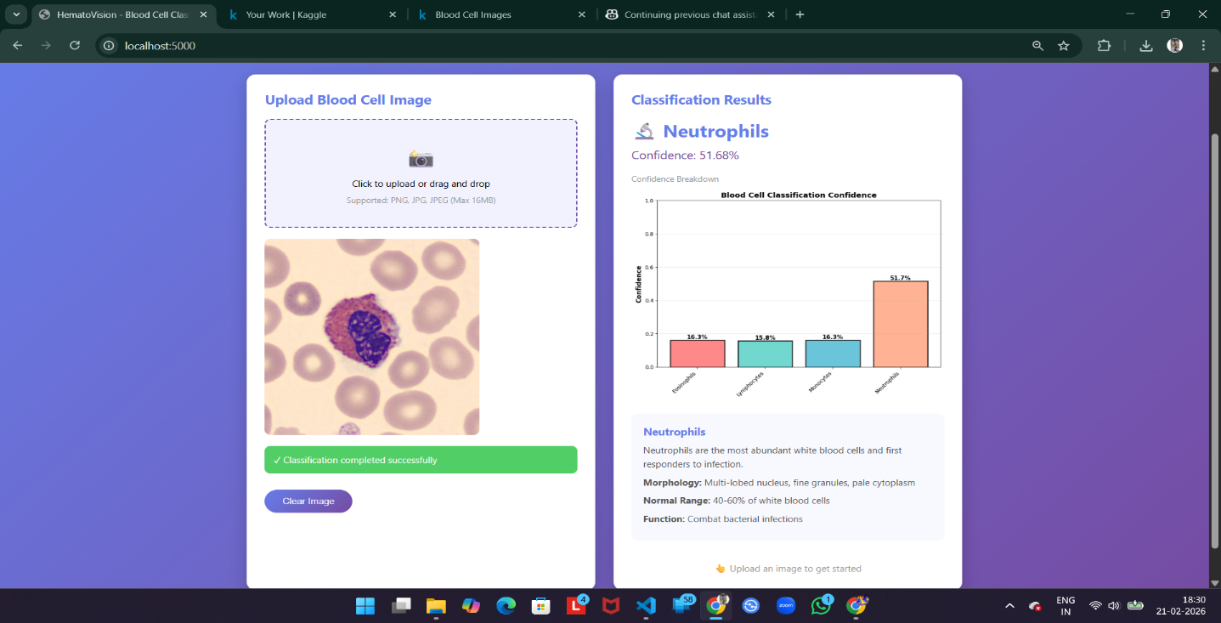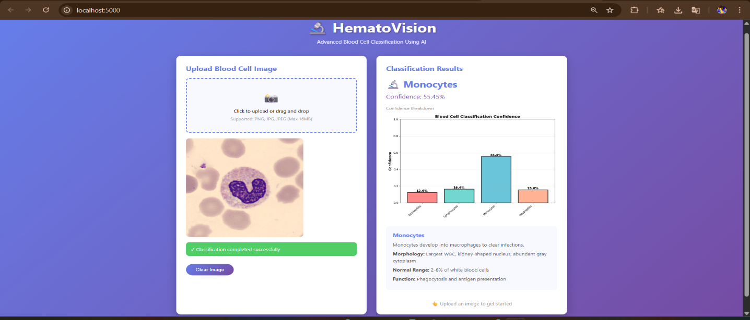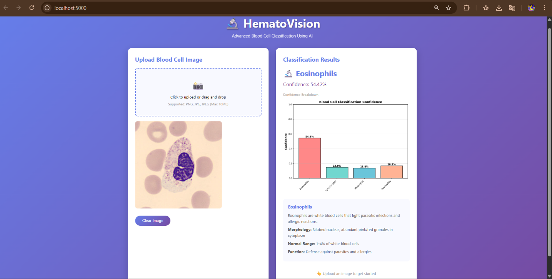

Acknowledgement
The development team of HematoVision wishes to express its sincere gratitude to all individuals and organisations whose guidance, resources, and encouragement made this project possible.

First and foremost, the team extends its deepest appreciation to SmartBridge Educational Services Pvt. Ltd. for providing the virtual internship platform that offered this invaluable opportunity to apply theoretical knowledge to a real-world AI problem in healthcare. The structured mentorship, curated learning resources, and industry-oriented project framework provided by SmartBridge have been instrumental in shaping the professional and technical competencies of the team members.

The team is especially grateful to the assigned SmartBridge project mentor, [Mentor Name – Placeholder], for their continuous guidance, timely feedback, and constructive critique throughout the project lifecycle. Their expertise in deep learning and medical image analysis significantly enriched the quality and rigour of the work presented in this documentation.

The team also thanks the faculty guides and mentors at their respective institutions for their academic oversight and encouragement throughout the duration of the internship project.

Gratitude is additionally extended to the open-source community, including the developers of TensorFlow, Keras, Flask, OpenCV, and Scikit-learn, whose freely available tools and documentation formed the technical foundation of this project. The creators of the publicly available annotated blood cell image dataset used for model training are also acknowledged for their contribution to the advancement of medical AI research.

Finally, the team acknowledges the unwavering support of family members and peers whose encouragement provided the motivation to persevere through the challenges encountered during the project.

References
The following references are cited in accordance with the IEEE citation style:

- [1] K. He, X. Zhang, S. Ren, and J. Sun, "Deep Residual Learning for Image Recognition," in Proc. IEEE Conf. Computer Vision and Pattern Recognition (CVPR), Las Vegas, NV, USA, pp. 770–778, 2016.
- [2] A. G. Howard, M. Zhu, B. Chen, D. Kalenichenko, W. Wang, T. Weyand, M. Andreetto, and H. Adam, "MobileNets: Efficient Convolutional Neural Networks for Mobile Vision Applications," arXiv:1704.04861, Apr. 2017.
- [3] M. Sandler, A. Howard, M. Zhu, A. Zhmoginov, and L.-C. Chen, "MobileNetV2: Inverted Residuals and Linear Bottlenecks," in Proc. IEEE/CVF CVPR, Salt Lake City, UT, USA, pp. 4510–4520, 2018.
- [4] G. H. Raabin, D. A. Matlob, M. Ghiasi, M. Rabbani, and K. Madadi, "A Large Dataset of White Blood Cells Containing Cell Locations and Types along with Segmented Nuclei and Cytoplasm," Scientific Reports, vol. 12, no. 1, p. 1123, 2022.
- [5] H. Kutlu, E. Avci, and F. Özyurt, "White Blood Cells Detection and Classification Based on Regional Convolutional Neural Networks," Medical Hypotheses, vol. 135, p. 109472, Feb. 2020.
- [6] A. Acevedo, A. Merino, S. Alférez, Á. Molina, L. Boldú, and J. Rodellar, "A New Lineage Classification of Reactive Leukocytes Based on Microscopic Images," Journal of Clinical Pathology, vol. 73, no. 8, pp. 481–488, 2020.
- [7] J. Yosinski, J. Clune, Y. Bengio, and H. Lipson, "How Transferable Are Features in Deep Neural Networks?" in Advances in Neural Information Processing Systems (NIPS), vol. 27, pp. 3320–3328, 2014.
- [8] R. R. Selvaraju, M. Cogswell, A. Das, R. Vedantam, D. Parikh, and D. Batra, "Grad-CAM: Visual Explanations from Deep Networks via Gradient-Based Localization," in Proc. IEEE ICCV, Venice, Italy, pp. 618–626, 2017.
- [9] N. Tajbakhsh et al., "Convolutional Neural Networks for Medical Image Analysis: Full Training or Fine Tuning?" IEEE Trans. Medical Imaging, vol. 35, no. 5, pp. 1299–1312, May 2016.
- [10] F. Chollet, "Xception: Deep Learning with Depthwise Separable Convolutions," in Proc. IEEE CVPR, Honolulu, HI, USA, pp. 1251–1258, 2017.
- [11] A. Krizhevsky, I. Sutskever, and G. E. Hinton, "ImageNet Classification with Deep Convolutional Neural Networks," in Advances in NIPS, vol. 25, pp. 1097–1105, 2012.
- [12] S. J. Pan and Q. Yang, "A Survey on Transfer Learning," IEEE Trans. Knowledge and Data Engineering, vol. 22, no. 10, pp. 1345–1359, Oct. 2010.

